E2E Testing of Filix Panini8 as School Admin

Screenshots with automation report
After Login to the filibot application as a dev.filix.panini8.com, the page will directly switch to Dashboard page, Teachers page, Students page, Cohorts page, Session Page, Reports page and Profile Page and by checking some functionality which is automated through selenium are passed. The Screenshots are in the following :-

Validation of Dashboard page
This is the extent report for the Dashboard Page that all the test cases are passed and it shows that no more bugs are there.

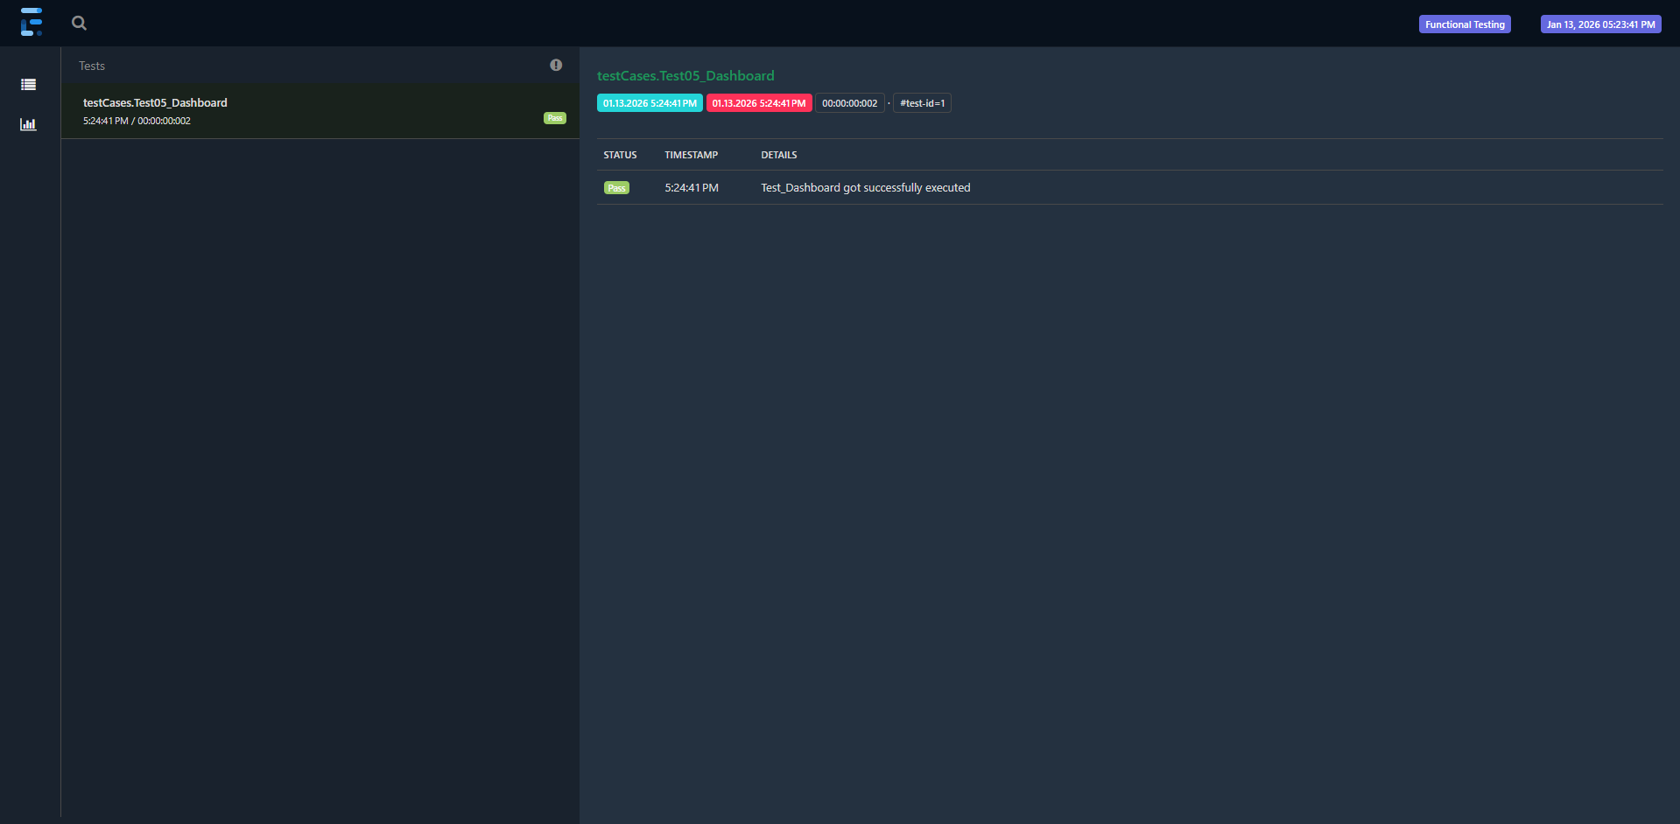

Validation of Teachers page
This is the extent report for the Teachers Page that all the test cases are passed and it shows that no more bugs are there.

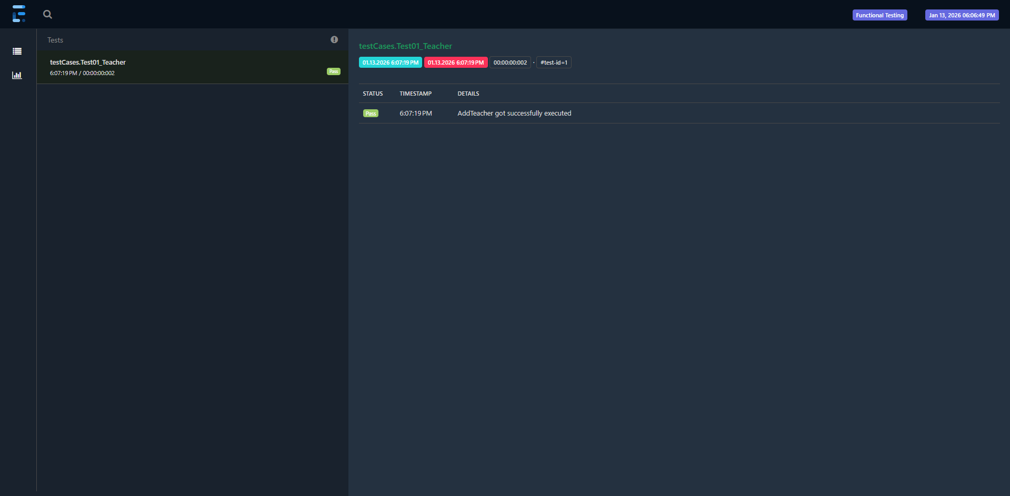

Validation of Students page
This is the extent report for the Students Page that all the test cases are passed and it shows that no more bugs are there.
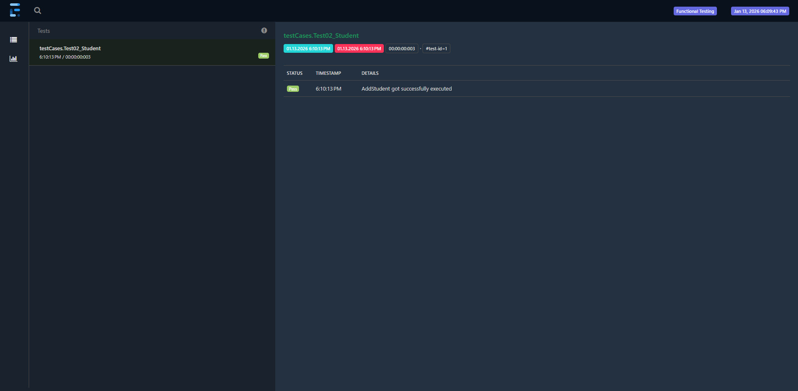

Validation of Reports page
This is the extent report for the Report Page that all the test cases are passed and it shows that no more bugs are there.

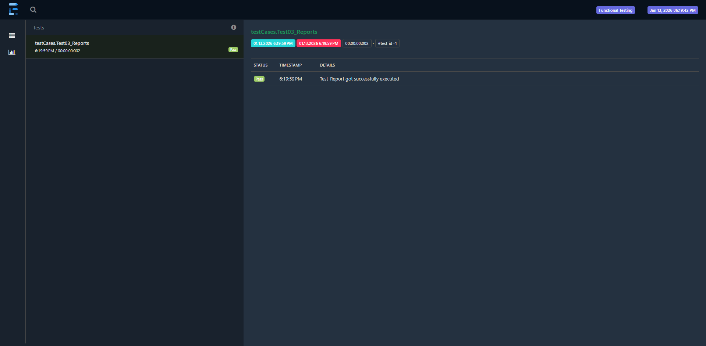

Validation of Cohorts page
This is the extent report for the Cohorts Page that all the test cases are passed and it shows that no more bugs are there.

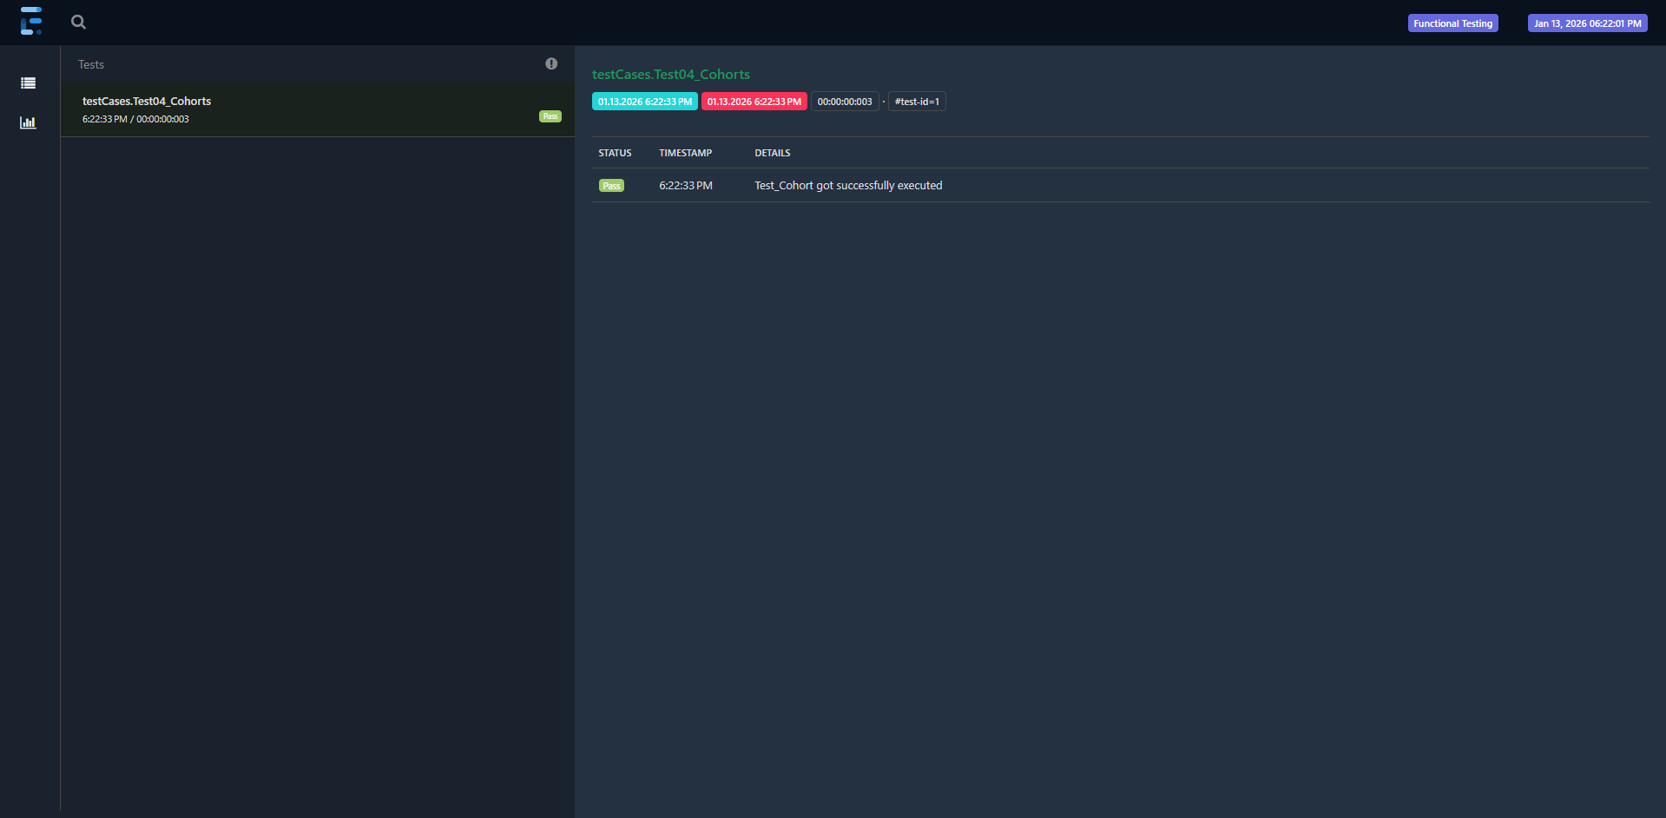

Validation of Profile page
This is the extent report for the Profile Page that all the test cases are passed and it shows that no more bugs are there.
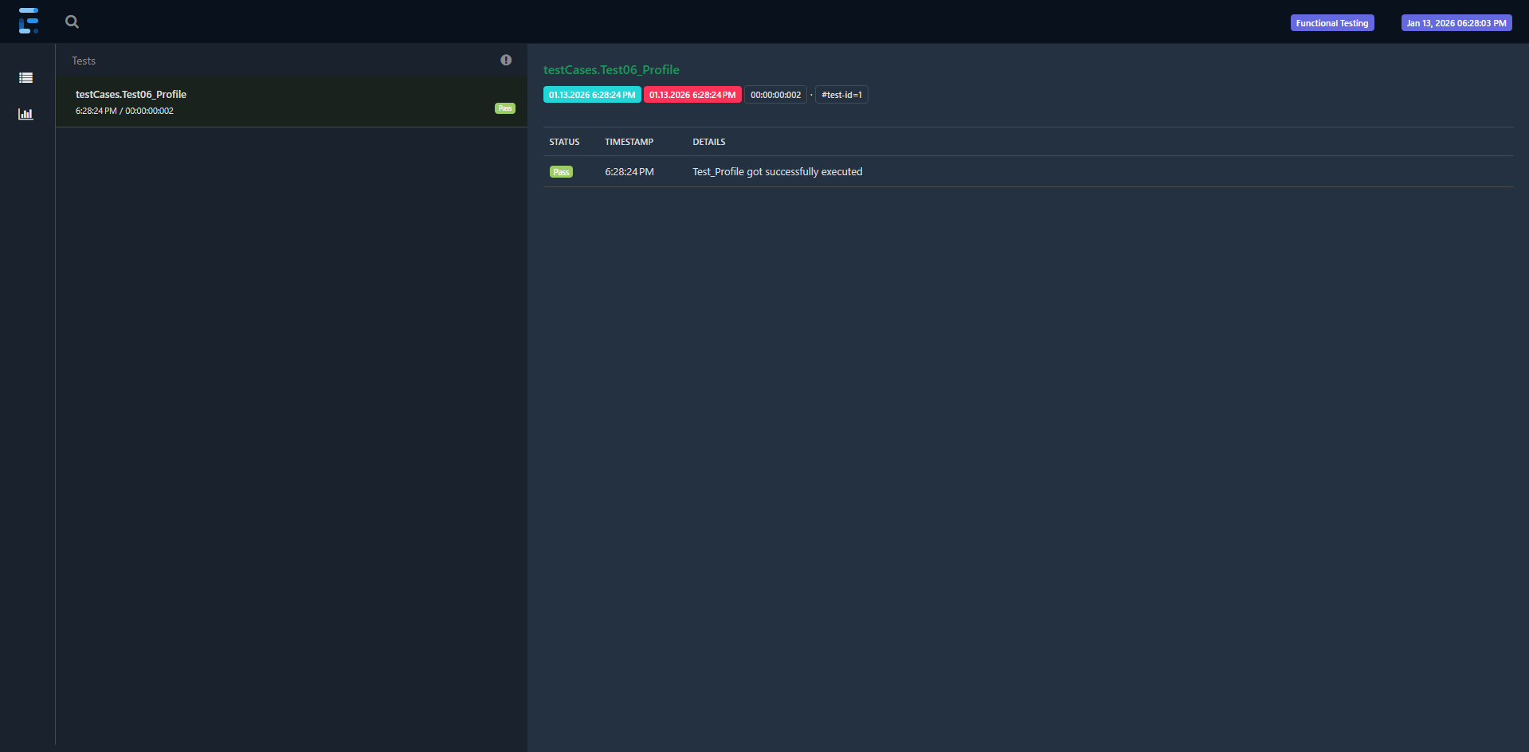

Validation of Themes page

This is the extent report for the Themes Page that the test cases are passed and it shows that no more bugs are there.

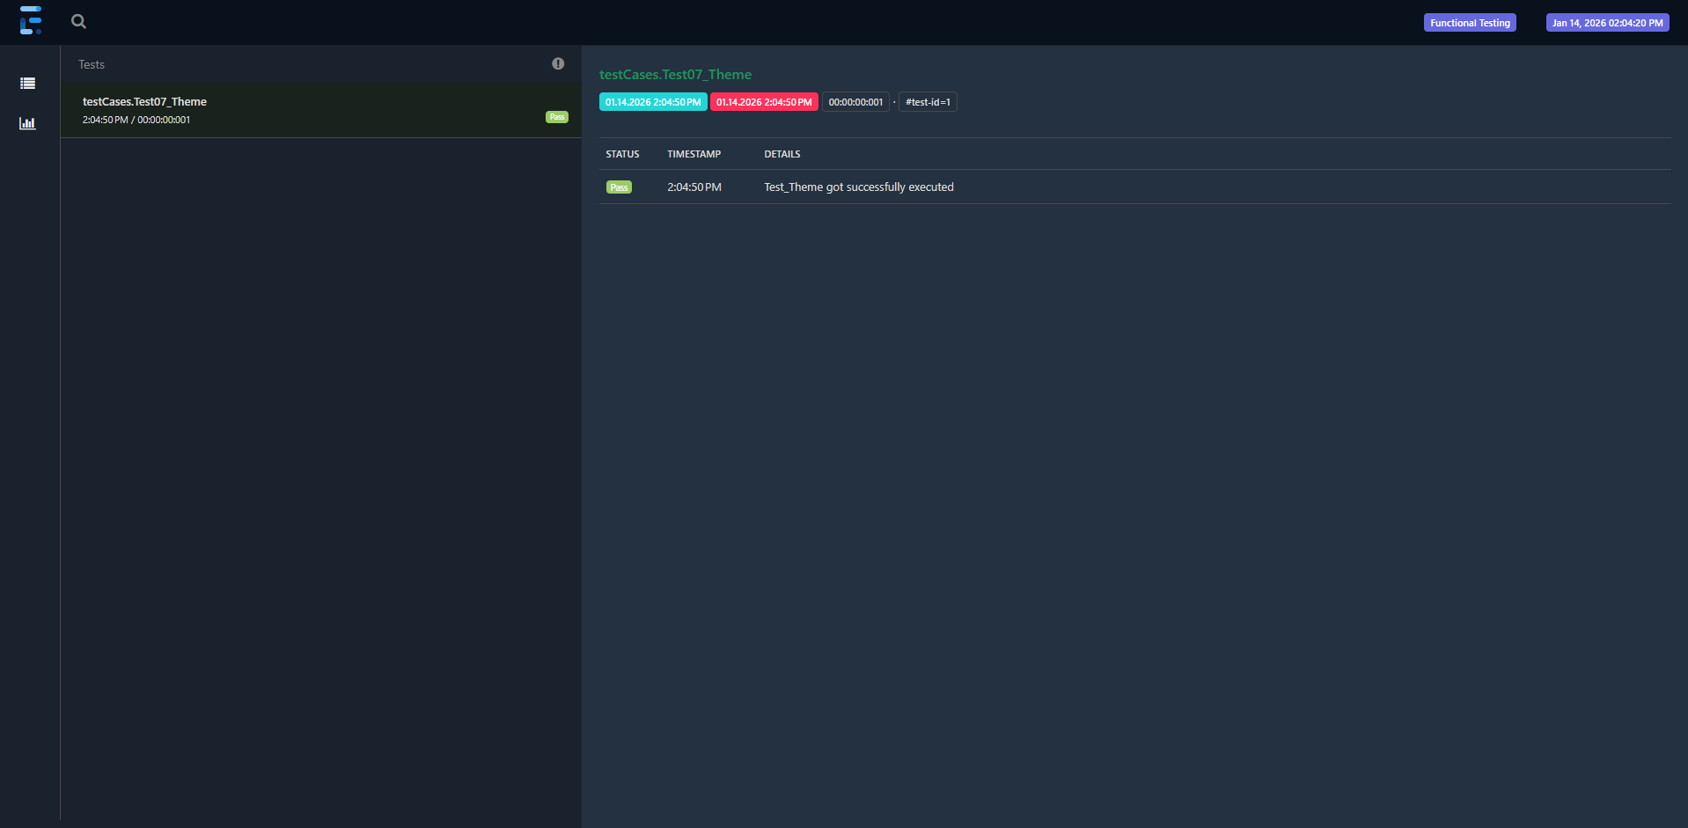

Validation of Chapters page
This is the extent report for the Chapters Page that the test cases have failed and it shows that it cannot progress further pages and found something issue or bug either on clicking Activities while creating a new chapter.

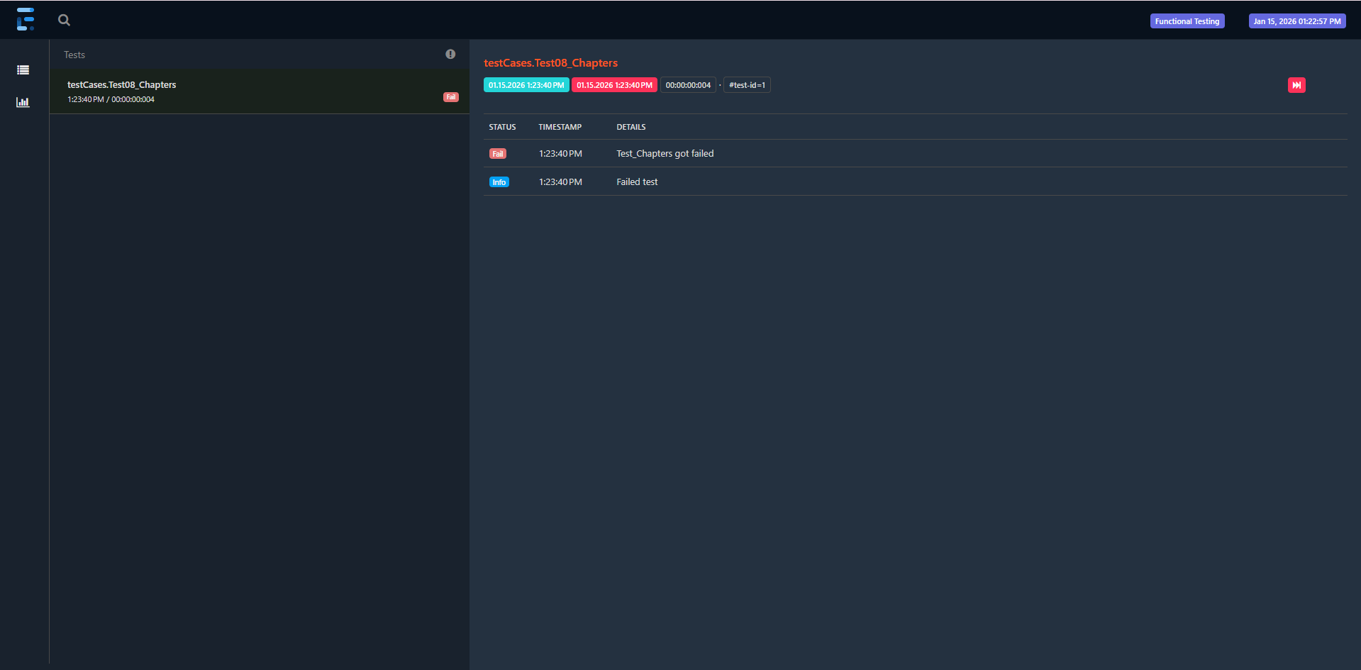

Validation of Activity page
This is the extent report for the Activity Page that the test cases are passed and it shows that no more bugs are there.
